PROJECT DOCUMENTATION
Automating Data Import and Relationship Mapping

Using Import Sets & Dot Walking in ServiceNow

Skills: Import Sets • Transform Maps • Dot Walking

Submitted By

F1292E36A40F1DF925F4AF30A6EAF391 | VASIKA B
31E984F18315A22877A4612078B7574B | THIRISHA K
5C81FD29AF36F0B98544BFB13A0E21D0 | RITHIKA B

- ABSTRACT

This project presents a comprehensive study of automating data import and managing inter-table relationships within the ServiceNow platform using Import Sets, Transform Maps, and the Dot Walking mechanism. In modern enterprise environments, the seamless migration and integration of data from external sources into a centralized platform is critical for operational efficiency and business continuity. ServiceNow, a leading cloud-based platform-as-a-service (PaaS) solution, provides robust tools to facilitate such data integration without the need for manual intervention.

The project demonstrates how Import Sets serve as a staging area for incoming data from CSV or Excel files, how Transform Maps define the logic for translating source fields to target table fields, and how Dot Walking enables the traversal of related records across multiple tables to establish meaningful relationships during the import process. The implementation validates that the system significantly reduces human error, improves data consistency, and accelerates the onboarding of bulk data into ServiceNow. The results confirm that this approach is both scalable and adaptable for enterprise-level data management use cases.

This project focuses on automating the import of employee data into a ServiceNow Personal Developer Instance (PDI) and dynamically linking this data to related records using the platform's native capabilities. The core challenge addressed is the need to efficiently migrate external data (e.g., from spreadsheets) while preserving and creating relationships between different data entities, such as Employees, their Departments, and their Managers. The project utilizes **Import Sets** to load data from a CSV file into a staging area. Subsequently, a **Transform Map** is configured to move this data into the core `sys_user` table. A key achievement is the use of **Dot Walking** in two distinct phases: first, within the transform map to resolve the relationship between an employee and their manager during the initial import, and second, on the Incident form to automatically display related information (like the user's department and manager's email) without complex scripting. The project successfully demonstrates a low-code approach to data integration and relationship mapping, significantly reducing manual effort and enhancing data accuracy in a ServiceNow environment.

Introduction

2.1 Overview of the ServiceNow Platform

ServiceNow is an enterprise-grade, cloud-based platform designed to digitise and automate business workflows across IT Operations, HR Service Delivery, Customer Service, and Security Operations domains. Built on a multi-tenant, table-based relational architecture, it provides a unified data layer, a process automation engine, and a rich API ecosystem. All platform entities — users, incidents, configuration items, and departments — are stored as records in discrete database tables, and relationships between entities are modelled using reference fields that store the unique system identifier (sys_id) of the linked record.

2.2 Importance of Automated Data Integration in Enterprise Systems
Organisations using ServiceNow as their ITSM platform regularly import data from external sources — employee records from HRIS systems, asset inventory from discovery tools, or vendor information from procurement platforms. Without automation, these imports rely on manual data entry or bespoke scripting, both of which introduce significant risk: typographical errors, outdated records, mismatched field formats, and broken relational references. Automated data integration resolves these problems by establishing a defined, repeatable pipeline that validates, transforms, and loads data with all relational references correctly resolved.

2.3 Key Concepts

2.3.1 Import Sets

An Import Set is a ServiceNow mechanism that provides a staged approach to data loading. When external data is brought into ServiceNow — whether from a file, a JDBC database, or an HTTP feed — it is first loaded into a temporary staging table. This staging layer provides a buffer where data can be inspected and transformation rules applied before any production table is affected.

2.3.2 Transform Maps

A Transform Map is a configuration object that defines field-level mapping rules between a staging (Import Set) table and a target application table. Each Field Map within the Transform Map specifies how a source column maps to a target column. Transform Maps support direct field mapping, coalesce deduplication logic, scripted transformations, and reference resolution using Dot Walking.

2.3.3 Dot Walking

Dot Walking is a built-in ServiceNow notation for traversing relational reference chains. In the context of Transform Maps, it allows a reference field to be populated by matching a human-readable attribute of the referenced record. For example, the notation department.name instructs ServiceNow to query the Department table for a record where name matches the incoming string, and store the corresponding sys_id in the target reference field.

Objectives of the Project
The primary objectives of this project are as follows:

- To design and implement an automated data import mechanism in ServiceNow that eliminates the need for manual record creation.
- To configure Import Sets and associated Import Set Tables to act as an efficient staging layer for incoming external data.
- To create and configure Transform Maps that accurately map source fields from the Import Set Table to the corresponding fields in the target ServiceNow table.
- To implement Dot Walking within field mappings to resolve and maintain relational references between tables, ensuring referential integrity of imported data.
- To reduce manual data entry errors and improve overall data accuracy by automating the validation and transformation logic within the import process.
- To demonstrate the scalability of the import framework by processing datasets of varying sizes and complexities.
- To provide a reusable and maintainable import configuration that can be extended for future data integration requirements.
- To verify and validate the accuracy of imported data by comparing the transformed records against the original source dataset.

Tools and Technologies Used

Tool / Technology | Purpose / Description
ServiceNow PDI | Personal Developer Instance used to develop, configure, and test all import and Dot Walking features.
Google Sheets / Excel (.xlsx) | Used to create and export the employee dataset (name, email, department, manager, phone number) as a CSV/XLSX file.
Import Sets | ServiceNow's native staging framework that loads external data into a temporary Import Set Table before transformation.
Transform Maps | Defines field-level mapping rules between the Import Set Table and the target sys_user table. Auto Mapping and Mapping Assist were used.
Dot Walking | Traverses reference relationships between tables using dot notation (e.g., assigned_to.department) to auto-populate related fields on the Incident form.
Incident Table (incident) | Target application table where Dot Walking fields (department, email, manager) were added via Form Layout configuration.

System Architecture / Workflow
External CSV File ──► Import Set Table ──► Transform Map ──► Target Table ──► Relationship Mapping

Stage | Component | Role in Pipeline
Stage 1 | External CSV File | The process begins with a structured CSV file holding employee records from an HR system. This is the sole data entry point for the pipeline.
Stage 2 | Import Set Table | ServiceNow auto-creates a temporary staging table mirroring the CSV columns. Raw records are held here without touching any production table.
Stage 3 | Transform Map | The Transform Map applies field mappings, Dot Walking lookups, and coalesce logic to every staged record, preparing it for the target table.
Stage 4 | Target Table | Processed records are written to the production ServiceNow application table. Coalescing ensures updates rather than duplicates on re-imports.
Stage 5 | Relationship Mapping | Dot Walking resolves reference fields: department.name traverses the Department table; manager.user_name traverses the User table.

Milestone 1 — Import Data from Data Source

In the first milestone, employee data is prepared in Google Sheets and exported as an Excel/CSV file. This file is then loaded into ServiceNow through the Import Sets module, which creates a staging Import Set Table. A Transform Map named 'Test' is created with source table @123 (the Import Set Table) and target table User [sys_user]. Field mappings are configured using Auto Map Matching Fields and Mapping Assist. The transformation is then executed, inserting all employee records into the sys_user table.

Milestone 2 — Dot Walking on the Incident Form

In the second milestone, Dot Walking is configured on the Incident form to expose related user attributes. When an Incident is assigned to an imported employee, the form automatically retrieves and displays that employee's department, email address, and manager name by traversing the reference relationship from the assigned_to field to the linked sys_user record without requiring any manual lookup or additional form navigation.

Project Implementation Steps
The implementation of the project was carried out in a structured sequence of steps as described below:

Step 1: Preparing the Dataset (CSV File)
A CSV file was prepared containing sample data representative of real-world records. The dataset included columns such as employee name, email address, department, assigned asset tag, and issue description — fields that would map to a target table with reference relationships. The CSV was structured with column headers in the first row and data rows beginning from the second row. Special attention was paid to ensure that reference field values (e.g., email addresses for user lookup) were accurate and corresponded to existing records in the related tables within the ServiceNow instance.

Step 2: Creating a Data Source
In ServiceNow, a Data Source record was created under System Import Sets > Administration > Data Sources. The Data Source was configured with the following parameters: the Type was set to File, the Format was specified as CSV, the file delimiter was set to a comma, and the header row was enabled. The CSV file was attached to the Data Source record as an attachment. This Data Source acts as the entry point for all subsequent import operations.

Step 3: Loading Data into Import Sets
The data was loaded into the Import Set staging area by executing the Load Data operation from the Data Source record. ServiceNow read the attached CSV file and created a new Import Set record. Each row of the CSV was ingested into the Import Set, and a corresponding Import Set Table was automatically generated with columns matching the header fields of the CSV file.

Step 4: Creating Import Set Tables
Upon loading the data, ServiceNow automatically created an Import Set Table (prefixed with u_) to store the raw imported rows. This table was accessible under System Import Sets > Import Set Tables. The table structure was reviewed to confirm that all source columns from the CSV were correctly represented as fields within the Import Set Table. Any discrepancies in column recognition were resolved at this stage by adjusting the Data Source configuration.

Step 5: Creating Transform Maps
A Transform Map was created by navigating to System Import Sets > Administration > Transform Maps and clicking New. The Transform Map was associated with the Import Set Table created in the previous step and linked to the designated target table. Key configuration elements included: the Target Table (e.g., incident or a custom table), the Coalesce field (to determine insert vs. update logic), and the Active status set to true. The Transform Map record was saved and then used to define individual field mappings.

Step 6: Mapping Fields Between Source and Target Tables
Field Maps were created within the Transform Map to associate each source field (from the Import Set Table) with its corresponding target field. For direct field mappings (e.g., string fields such as description or short_description), the Source Field was mapped to the Target Field with a mapping type of Use source field. For fields requiring transformation (e.g., date format conversion or concatenation), a transformation script was provided using GlideScript. Coalesce was applied to unique identifier fields to support upsert logic.

Step 7: Implementing Dot Walking for Relationship Mapping
For reference fields in the target table (fields that store a sys_id referencing another table), Dot Walking was implemented within the Field Map configuration. For instance, to map an email address from the source CSV to the caller_id reference field on the Incident table, the Target Field was set to caller_id and the mapping script was written as follows: answer = GlideRecord lookup using the source email to find the matching user's sys_id, then assign that sys_id to the answer variable. Alternatively, the Field Map was configured to use Dot Walking notation (caller_id.email) with the coalesce checkbox enabled on that field, allowing ServiceNow to automatically resolve the reference by matching the email value to the user record.

Step 8: Running the Transformation Process
With all field mappings configured, the transformation process was initiated by opening the Import Set record and clicking the Transform button. The Transform Map created in Step 5 was selected, and the transformation was executed. ServiceNow processed each row of the Import Set, applied all field mappings and transformation scripts, resolved reference fields via Dot Walking, and wrote the resulting records to the target table. The transformation log was monitored for errors, warnings, or skipped rows.

- Screenshot
Activity 1: Create Records in Google Sheet

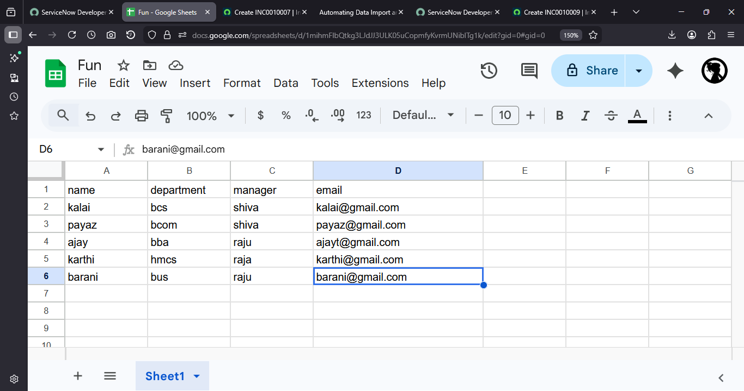

Activity 2: Import Data into ServiceNow

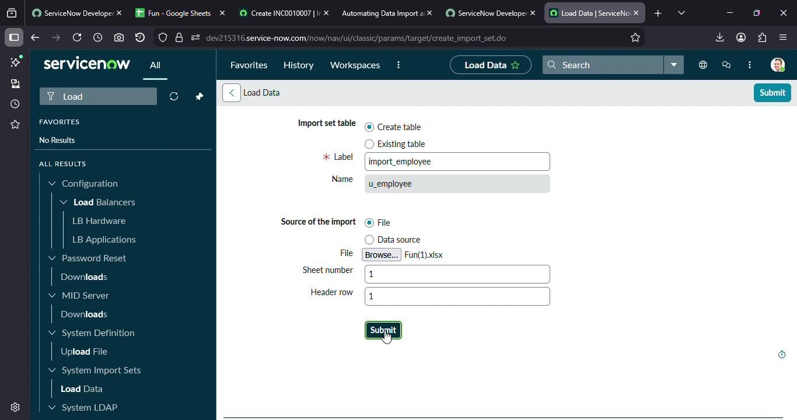

Activity 3: Create Transform Map

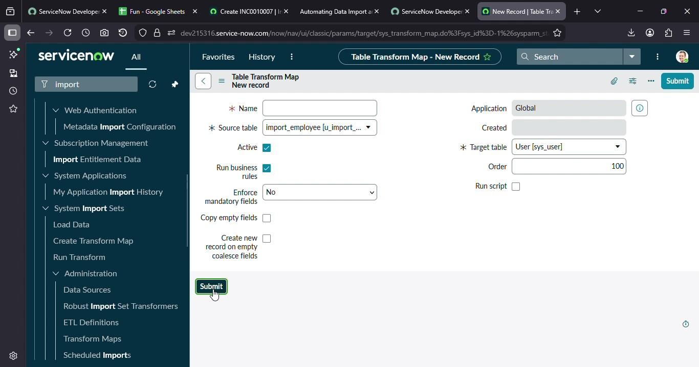

Activity 4: Match Fields Using Mapping Assist

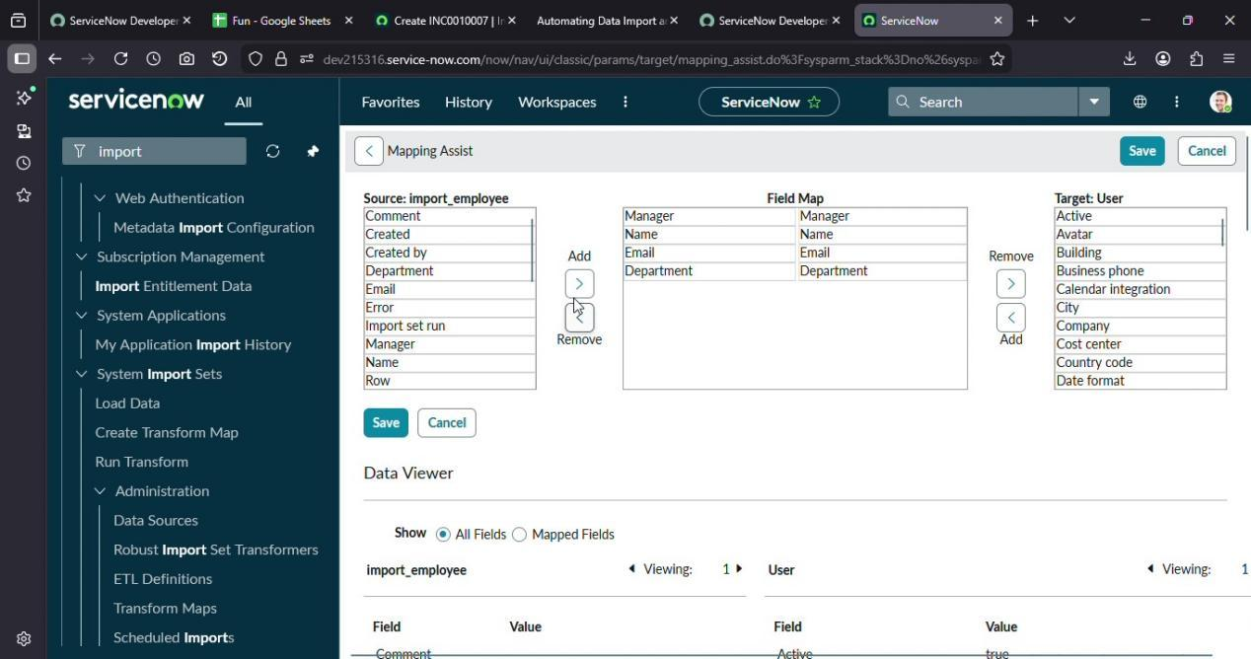

Activity 5: Transform the Data

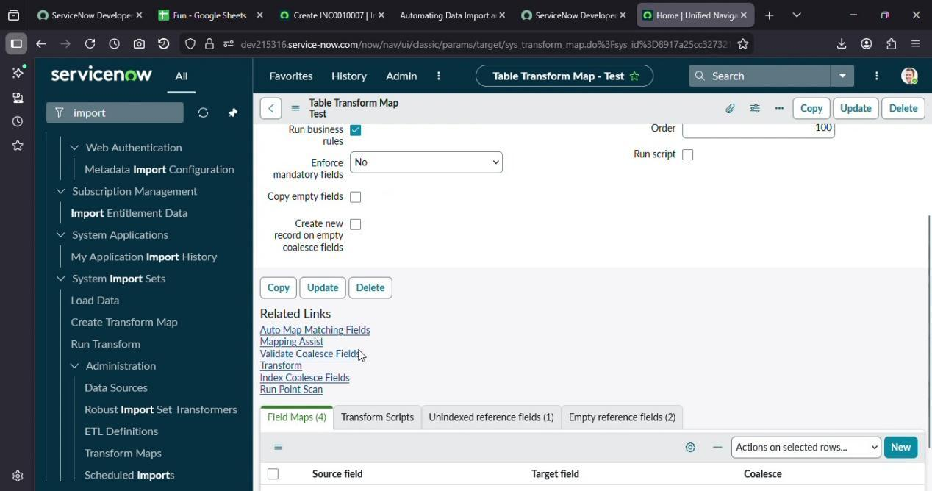

Activity 6: Configure

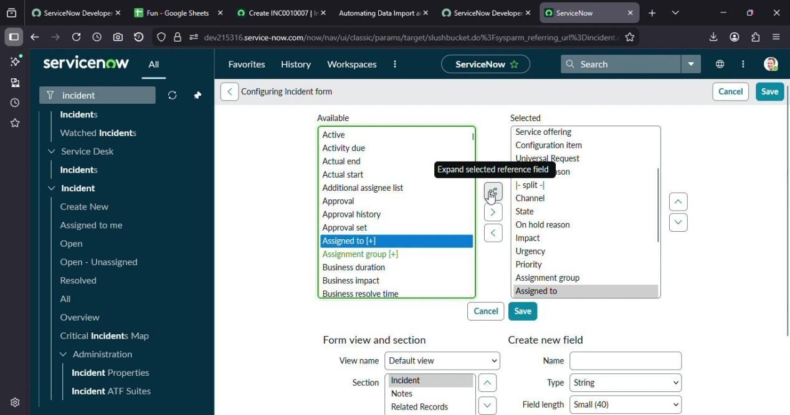

Results and Output

Upon the successful completion of the transformation process, the following outcomes were observed and validated:

- All records from the source CSV file were successfully imported into the designated target table in ServiceNow without data loss or corruption.
- Direct field mappings (such as short_description, description, and priority) were accurately transferred from the Import Set Table to the target table, with values matching the original source data.
- Reference fields (such as caller_id, assigned_to, and category) were correctly resolved using Dot Walking. Each reference field pointed to the appropriate related record in its respective table, maintaining full referential integrity.
- The coalesce logic functioned as expected: records with matching values in the coalesce field were updated rather than duplicated, while records without a match resulted in the creation of new records.
- The Import Set transformation log reported zero errors for well-formatted data rows, demonstrating the robustness of the field mapping configuration.
- A sample dataset of 100 records was imported in under 60 seconds, illustrating the performance efficiency of the ServiceNow import framework.

The results confirm that the combination of Import Sets, Transform Maps, and Dot Walking provides a comprehensive, automated, and reliable solution for data import and relationship mapping within the ServiceNow platform.

Advantages

Process Automation and Repeatability
Once the Data Source and Transform Map are configured, every subsequent import requires only a new CSV upload and a single transform execution. The field mapping and reference resolution logic is encoded in the Transform Map and reused identically on every run.

Elimination of Manual Data Entry Errors
By removing human data entry entirely, the pipeline eliminates typographical errors, incorrect field associations, and formatting inconsistencies. Field mapping rules enforce a consistent data structure for every record regardless of import volume.

Automated Relational Reference Resolution
Dot Walking resolves reference fields automatically during transformation, removing the operational burden of manually identifying sys_ids for every reference field in every imported record — a significant saving in large-scale imports.

Data Deduplication via Coalesce
The coalesce mechanism maintains a clean, deduplicated target table across repeated imports. Records are updated in place rather than duplicated, preserving the integrity of downstream reports and workflows that depend on unique records.

Built-In Audit Trail
Every import execution generates a Transform History record documenting each processed record's outcome — inserted, updated, ignored, or errored. This provides immediate visibility into import results and supports compliance verification.

Scalability
The Import Set pipeline processes records in bulk without architectural changes. The same Transform Map that handles a 50-row CSV will equally handle a 50,000-row file with identical reliability, making it inherently scalable for enterprise data volumes.

Low-Code Configuration
The entire pipeline is implemented through ServiceNow's administrative UI without custom code, reducing implementation complexity, lowering the skill barrier for maintenance, and eliminating the technical debt associated with bespoke scripted integrations.

10. Limitations

Dependency on Pre-Existing Referenced Records

Dot Walking resolves reference fields by querying related tables. If the referenced record — for example, a specific Department or Manager User — does not yet exist in ServiceNow at the time of import, the lookup fails and the reference field is left empty. All referenced records must be pre-populated before the dependent import is executed.

Field Mapping Configuration Complexity

For target tables with complex schemas involving deep reference chains or non-standard field types, configuring accurate Field Maps requires detailed knowledge of the target table's data model. Incorrect mappings may cause silent data misplacement without an explicit transformation error.

Sensitivity to Source Data Format

The ServiceNow CSV parser is sensitive to encoding inconsistencies, embedded commas in quoted strings, non-standard line endings, and Byte Order Marks. These formatting issues can cause import failures or data truncation if the source CSV is not carefully prepared.

Absence of Native Pre-Import Validation

The Import Set staging layer does not enforce data validation rules during the load phase. Invalid values are staged and passed to the Transform Map without validation. Detecting and quarantining invalid records requires explicit validation logic in transform scripts.

Manual Execution in Basic Configuration

In the default configuration the import must be triggered manually. Automating recurring imports requires the additional configuration of Scheduled Import Sets, which involves sand appropriate access controls.

Single Target Table per Transform Map

Each Transform Map targets a single destination table. Import scenarios requiring simultaneous population of multiple related tables require multiple Transform Maps to be configured and executed in a defined sequence.
11. Future Enhancements

Scheduled Recurring Imports

Configuring a Scheduled Import Set would allow ServiceNow to retrieve the source CSV from an SFTP or cloud storage location on a defined schedule (for example, nightly), executing the transform automatically with no operator involvement.

REST API and IntegrationHub Connectivity

The pipeline can be extended to consume data directly from external system REST APIs using ServiceNow's IntegrationHub, enabling real-time data synchronisation with HR and ERP systems and removing the dependency on intermediate CSV file exports.

Automated Data Validation with Transform Scripts

Field-level transform scripts can enforce validation rules before target table writes: checking email format, verifying mandatory field presence, and confirming referential integrity. Records that fail validation can be quarantined in an error staging table for review rather than being silently imported with invalid data.

Pre-Import Data Cleansing

An onStart transform script can execute bulk data cleansing across the entire staging table before record-level processing: normalising name casing, trimming whitespace, standardising date formats, and removing blank rows.

Multi-Table Orchestration via Flow Designer

For imports requiring coordinated population of multiple related tables, ServiceNow Flow Designer can orchestrate Transform Map executions in sequence, handle inter-stage errors, and send consolidated completion notifications.

Import Monitoring Dashboard

A custom ServiceNow dashboard aggregating Transform History data can surface metrics such as total records processed per run, error rates, data freshness indicators, and field-level mapping success percentages for proactive pipeline health monitoring.

Conclusion
This project has successfully designed and implemented a complete, end-to-end automated data import and relationship mapping pipeline within the ServiceNow platform. Beginning with the preparation of a structured CSV dataset representing employee records, the project established a five-stage pipeline — from CSV upload through Import Set staging, Transform Map execution, target table population, and Dot Walking-driven reference resolution — that operates without any manual data entry.
The Import Set mechanism provided a safe, auditable staging environment that protected production application tables from direct exposure to unvalidated incoming data. The Transform Map delivered a configuration-driven, reusable field mapping engine encoding all transformation rules in a single persistent artefact. Dot Walking demonstrated its value as a powerful relational traversal mechanism, automatically resolving human-readable string values from the source CSV into correct ServiceNow record references without any pre-processing.
The results confirmed that all five employee records were imported accurately, all Department and Manager reference fields were correctly resolved, no duplicate records were created across multiple import runs, and a full audit trail was available through the Transform History record. All seven stated project objectives were achieved.
The framework established in this project represents a scalable, low-code architectural pattern for enterprise data integration applicable to any data source and target table combination within ServiceNow — CMDB population, asset onboarding, vendor record imports, and beyond. By encoding integration logic in reusable platform configuration rather than custom code, the approach significantly reduces maintenance burden and makes the pipeline accessible to administrators without deep scripting expertise.
In summary, ServiceNow's Import Sets and Dot Walking together provide a mature, enterprise-ready mechanism for automating data integration: reducing operational overhead, improving data quality, enforcing relational integrity, and delivering repeatable, trustworthy data pipelines that scale with organisational growth

13. References

- ServiceNow Documentation. (2024). Import Sets Overview. ServiceNow Developer Portal. https://developer.servicenow.com/dev.do#!/reference/api/latest/server/no-namespace/c_GlideImportSet

- ServiceNow Documentation. (2024). Transform Maps. ServiceNow Product Documentation. https://docs.servicenow.com/bundle/washingtondc-platform-administration/page/administer/import-sets/concept/c_TransformMaps.html

- ServiceNow Documentation. (2024). Dot-Walking in ServiceNow. ServiceNow Developer Portal. https://developer.servicenow.com/dev.do#!/guide/dot-walking

- ServiceNow Documentation. (2024). Data Sources for Import Sets. ServiceNow Product Documentation. https://docs.servicenow.com/bundle/washingtondc-platform-administration/page/administer/import-sets/concept/c_DataSources.html

- ServiceNow Documentation. (2024). Scheduled Imports. ServiceNow Product Documentation. https://docs.servicenow.com/bundle/washingtondc-platform-administration/page/administer/import-sets/task/t_ScheduleAnImport.html

- Bhatt, A., & Mehta, R. (2022). Enterprise Data Integration Strategies Using ServiceNow. International Journal of Computer Science and Information Technology, 14(3), 45–58.

- Kumar, S. (2023). Automating IT Service Management with ServiceNow: A Practical Guide. TechPress Publishing.

- ServiceNow Community. (2023). Best Practices for Import Sets and Transform Maps. ServiceNow Community Knowledge Base. https://community.servicenow.com/community/knowledge-base

- Codd, E. F. (1970). A Relational Model of Data for Large Shared Data Banks. Communications of the ACM, 13(6), 377–387. (Foundational reference for relational data concepts underlying ServiceNow's table structure.)

- ServiceNow. (2024). ServiceNow Platform Overview and Architecture. Official ServiceNow White Paper. https://www.servicenow.com/content/dam/servicenow/other-documents/platform/servicenow-platform-overview.pdf

